Implementation of ANN on Iris Dataset

The algorithm used here is Artificial Neural Network(ANN). The term "Artificial Neural Network" is derived from Biological neural networks that develop the structure of a human brain. Similar to the human brain that has neurons interconnected to one another, artificial neural networks also have neurons that are interconnected to one another in various layers of the networks. These neurons are known as nodes.

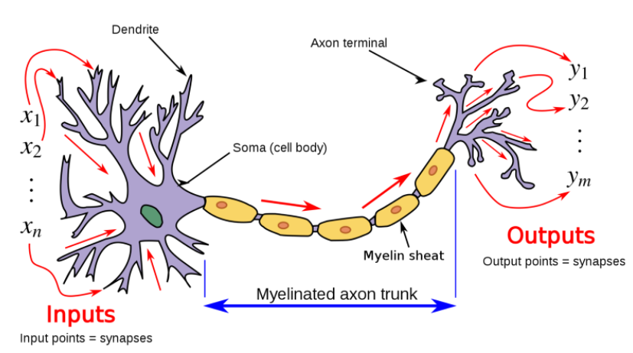

Sampling

The dataset we have taken here is iris dataset.

The Iris dataset was used in R.A. Fisher's classic 1936 paper, [The Use of Multiple Measurements in Taxonomic Problems](http://rcs.chemometrics.ru/Tutorials/classification/Fisher.pdf), and can also be found on the [UCI Machine Learning Repository](http://archive.ics.uci.edu/ml/).

It includes three iris species with 50 samples each as well as some properties about each flower. One flower species is linearly separable from the other two, but the other two are not linearly separable from each other.

The columns in this dataset are:

* Id
* SepalLengthCm
* SepalWidthCm
* PetalLengthCm
* PetalWidthCm
* Species

The total number of samples is 150,where each class has 50 samples each.

We took the data and took 80% for training and 20% for testing.

Parameter update on epoch

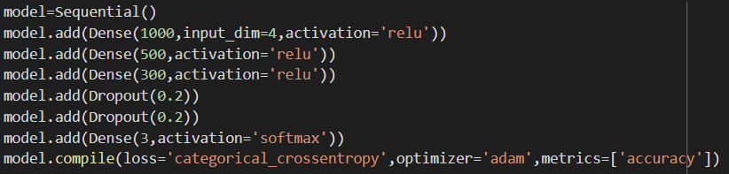

Final parameter value

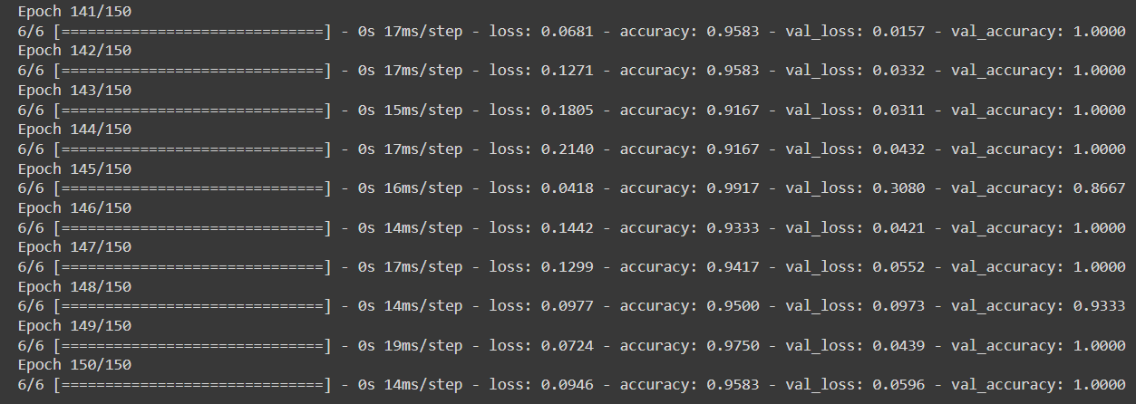

Train vs Test loss

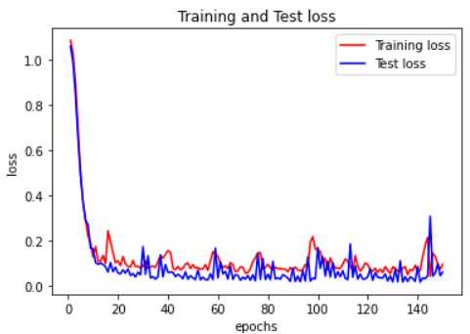

Train vs Test Accuracy

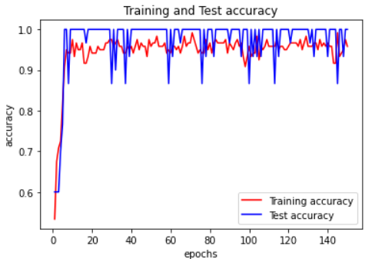

F1 score

